AP Calc AB Name: _______________

______________ _____________

WS Assessment

Target 10:

Rate of changes in applied context

**I can:**

* Interpret the meaning of a derivative in context
* Calculate rates of change in applied context
* Interpret rate of change in applied context

Unit 4: Contextual Applications of Differentiation

HW Target 10

Unit 4 Progress Check MCQ

**Instantaneous vs Average Rate of Change** (IROC vs AROC)

Decide whether the phrase used in each of the following problems corresponds to an instantaneous rate of change or an average rate of change. Indicate your decision by writing its corresponding IROC or AROC

1. Over the time interval from t = 2 to t = 5

2. After three seconds have elapsed

3. At noon

4. During the first five minutes

5. Over the twelve-hour time period

6. When t = 7 hours

**Phrases for Rates of Change**

Match each phrase in the first column of the table with the corresponding term or set of units in the second column.

|  |  |
| --- | --- |
| 1. instantaneous rate of change of position | A. velocity |
| 2. possible units for acceleration | B. acceleration |
| 3. units for instantaneous rate of change of volume, V(t) , where V is measured in gallons and t is measured in hours | C. gallons per hour per hour |
| 4. possible units for position | D. meters |
| 5. instantaneous rate of change of velocity | E. meters per second |
| 6. possible units for velocity | F. meters per second per second |
| 7. units for instantaneous rate of change of R(t) , R is measured in gallons per hour and t is measured in hours | G. gallons per hour |

**Displacement, Velocity, Acceleration**

Change your grapher to parametric mode (MODE, highlight PAR instead of FUNC )

Press WINDOW, set T from 0 → 10; Tstep = 0.05 (slow movement)

X from -80 to 150; Y from -1 to 4

An object moves in the x direction in such a way that its displacement from y-axis is

s(t) = 3t3 – 30t2 + 64t + 57 for t > 0

enter it to calculator: X1 = 3t3 – 30t2 + 64t + 57 Y1 = 1

Set the graph line as circle dash (move cursor to the left of X1, press Enter twice)

Press graph, observe the movement and use TABLE to fill in the blank that describe the displacement follow:

*The object starts at x =? ________ and moves to the ? (left / right). It stops at x = ? ______,*

*makes a U turn, moves to the ? (left / right). It stops at x = ? ________, make a U turn, moves to the ? (left / right). It stops at x = ? ______*

Now enter the function of the object's velocity (derivative of displacement)

v = s '(t) = ? ___________________________

Enter this function on X2, on Y2 type Y2 = 2 (Or you can use X2 = nDeriv(X1, T, T) )

Set the graph line as circle dash (move cursor to the left of X1, press Enter twice)

Press graph, observe the movement and use TABLE to fill in the blank that describe the displacement follow:

*The object starts at x =? ________ and moves to the ? (left / right). It stops at x = ? ______,*

*makes a U turn, moves to the ? (left / right). It stops at x = ? ________, make a U turn, moves to the ? (left / right). It stops at x = ? ______*

Now enter the function of the object's acceleration (derivative of velocity)

a = v '(t) = ? ___________________________

Enter this function on X3, on Y3 type Y3 = 3 (Or you can use X3 = nDeriv(X2, T, T) )

Set the graph line as circle dash (move cursor to the left of X1, press Enter twice)

Press graph, observe the movement and use TABLE to fill in the blank that describe the displacement follow:

*The object starts at x =? ________ and moves to the ? (left / right). It stops at x = ? ______,*

*makes a U turn, moves to the ? (left / right). It stops at x = ? ________, make a U turn, moves to the ? (left / right). It stops at x = ? ______*

Now use TABLE to fill in the table and sketch the graph of those three on the same axes

|  |  |  |  |  |  |  |  |  |  |  |
| --- | --- | --- | --- | --- | --- | --- | --- | --- | --- | --- |
| Time (hr) | 0 | 1 | 2 | 3 | 4 | 5 | 6 | 7 | 8 | 9 |
| Displacement s = X1 |  |  |  |  |  |  |  |  |  |  |
| Velocity  v = X2 |  |  |  |  |  |  |  |  |  |  |
| Acceleration a = X3 |  |  |  |  |  |  |  |  |  |  |

Graph the info from the table below. Remember the horizontal axis is for time (hr), it is run from 0 to 10. Use different line style for Displacement, Velocity and Acceleration

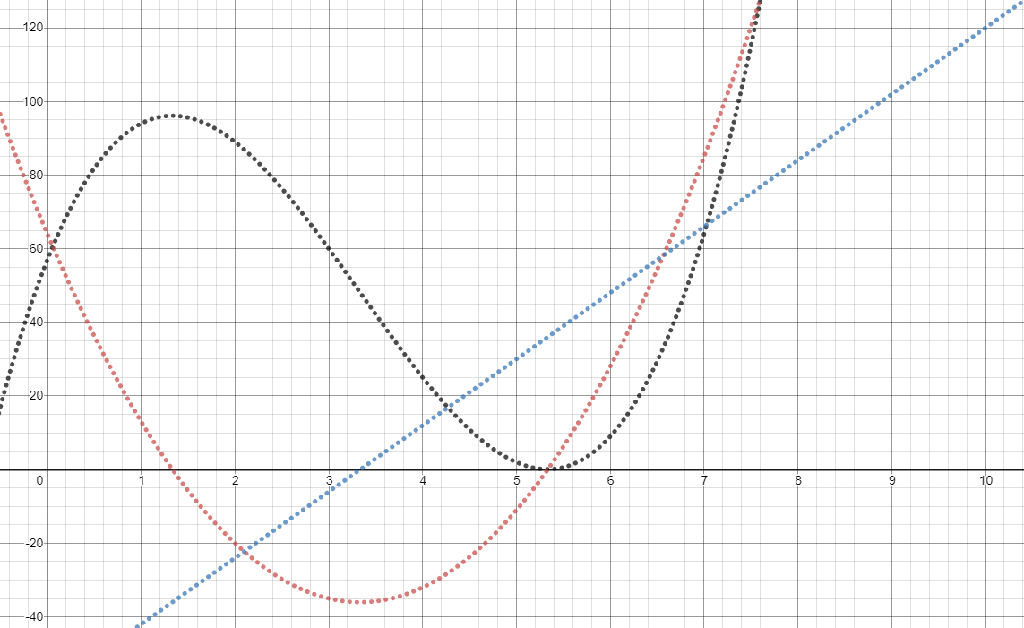BTW, what is the unit of each?

Displacement's unit =

Velocity's unit =

Acceleration's unit =

From the graph and the table answer the following questions

Let say, the object is a moving car, describe what happens at the time t in term of position, speed and acceleration? (where it's heading, run forward/backward, slowing down/speeding up). Justify your reasoning using the function's value.

|  |  |
| --- | --- |
| Time  1 |  |

|  |  |
| --- | --- |
| 2 |  |
| 5 |  |
| 7 |  |

At what time in the close interval [0, 8] displacement function has its local maximum (called relative maximum), global maximum (called absolute maximum)? What is meaning of this maximum value, in term of function and in term of a car?

At what time in the close interval [0, 8] displacement function has its local minimum (called relative minimum), global minimum (called absolute minimum)? What is meaning of this minimum value, in term of function and in term of a car?

**Some definition to be remembered**:

Let s = f(t) is the displacement function then

average velocity = $\frac{Δs}{Δt}$ instantaneous velocity v(t) = $\frac{ds}{dt}$ = s'(t) speed = | v(t) |

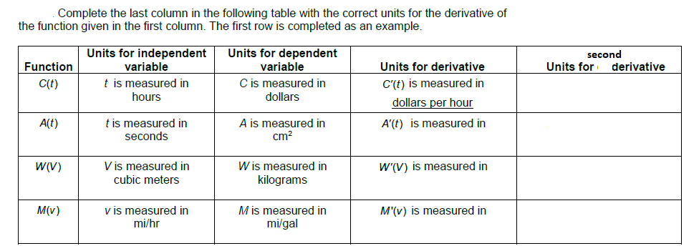acceleration $a\left(t\right)=\frac{dv}{dt}=\frac{d^{2}s}{{dt}^{2} }$ = v '(t) = s''(t) (second order of derivative)

A particle move along a line so that its positions at any time t ≥ 0 is given by the function

s(t) = t2 – 4t + 3, where s is measured in meters and t is measured in seconds.

a. Find the displacement of the particle during the first 2 seconds? _______________

b. Find the average velocity of the particle during the first 4 seconds? _____________

c. Find the instantaneous velocity of the particle when t = 4? ____________________

d. Find the acceleration of the particle when t = 4 ? ____________________________

e. Describe the motion of the particle. At what values of t does the particle change direction?

A dynamite blast propels a heavy rock straight up with a launch velocity of 160 ft/sec (about 109 mph). It reaches a height of s = 160t – 16t2 ft after t seconds.

a. How high does the rock go?

b. What is the velocity and speed of the rock when it is 256 ft above the ground on the

way up? on the way down?

c. What is the acceleration of the rock at any time t during its flight (after the blast)?

d. When does the rock hit the ground?

*Derivatives in Economics: Engineers use the terms velocity and acceleration to refer to the derivatives of functions describing motion. Economists, too, have a specialized vocabulary for rates of change and derivatives. They call them marginals. In a manufacturing operation, the cost of production c(x) is a function of x, the number of units produced. The marginal cost of production is the rate of change of cost with respect to the level of production, so it is dc/dx.*

Suppose it costs c(x) = x3 – 6x2 + 15x dollars to produce x radiators when 8 to 10 radiators are produced, and that r(x) = x3 – 3x2 + 12x gives the dollar revenue from selling x radiators. Your shop currently produces 10 radiators a day. Find the marginal cost and marginal revenue.

Suppose that the dollar cost of producing x washing machines is c(x) = 2000 + 100x – 0.1x2.

a. Find the average cost of producing 100 washing machines.

b. Find the marginal cost when 100 machines are produced.

c. Show that the marginal cost when 100 washing machines are produced is approximately the cost of producing one more washing machine after the first 100 have been made, by calculating the latter cost directly.

Suppose the weekly revenue in dollars from selling x custom-made office desks is

$r(x)=2000\left(1-\frac{1}{x+1}\right)$

a. Draw the graph of r. What values of x make sense in this problem situation?

b. Find the marginal revenue when x desks are sold.

c. Use the function r '(x) to estimate the increase in revenue that will result from increasing sales from 5 desks a week to 6 desks a week.

*Sensitivity to Change. When a small change in x produces a large change in the value of a function f x, we say that the function is relatively sensitive to changes in x. The derivative f x is a measure of this sensitivity.*

The monthly profit (in thousands dollars) of a software company is given by $P(x)=\frac{10}{1+50⋅2^{5-0.1x}}$

where x is the number of software packages sold. Graph P(x).

a. What values of x make sense in the problem situation?

b. Use NDER to graph P'(x). Show me both for stamp _____________

For what values of x is P relatively sensitive to changes in x?

c. What is the profit when the marginal profit is greatest?

d. What is the marginal profit when 50 units are sold? 100 units, 125 units, 150 units, 175 units, and 300 units?

e. What is lim x→∞ P(x)? What is the maximum profit possible?

f. Is there a practical explanation to the maximum profit answer? Explain your reasoning

Assessment

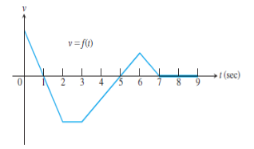

The accompanying figure shows the velocity v = f(t) of a particle moving on a coordinate line.

When is the particle’s acceleration positive? Negative? zero?

When does the particle move forward? move backward? speed up? slow down?

When does the particle move at its greatest speed?

When does the particle stand still for more than an instant?

Find the rate of change of the area A of a circle with respect to its radius r (dA / dr)

Evaluate the rate of change of A at r = 5 and at r = 10. State its unit

Write the area A of a circle as a function of the circumference C.

Find the (instantaneous) rate of change of the area A with respect to the circumference

C (dA / dC)

Evaluate the rate of change of A at C = π and C = 6π. . State its unit

Write the volume V of a cube as a function of the side length s.

Find the (instantaneous) rate of change of the volume V with respect to a side s (dV / ds)

Evaluate the rate of change of V at s = 1 and s = 5. State its units

A square of side length s is inscribed in a circle of radius r. Write the area A of the square as a function of the radius r of the circle. Find the (instantaneous) rate of change of the area A with respect to the radius r of the circle (dA / dr)

Evaluate the rate of change of A at r = 1 and r = 8.

Water is flowing into a tank so that the volume of water in the tank, in liters, after t seconds is given by the function $V\left(t\right)=74-9e^{-0.3t}$ 0.3 . Find and explain the meaning of the following value?

V(15) = V’(15)=

____________________________________ _________________________________